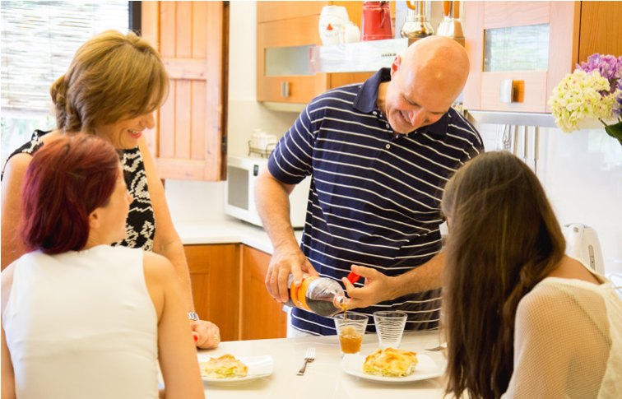
Student Homestay Manual EC Vancouver

www.ecenglish.com
Arriving in a new country is always exciting, but if it is your first time here, things can seem a bit new and unknown. So, to help you feel as comfortable as possible in your homestay, we’ve put together a little welcome guide to help you understand your homestay experience and hopefully get an understanding of life in Vancouver and its culture. And if you have any other questions, do ask your host family who will be delighted to help you.

What to Expect from Your Homestay
Living in someone else’s home can be interesting but may also be a little stressful. Sometimes you may feel homesick, and it might be a challenge to adapt to how other households do things. You are also adapting to a different culture and language. Knowing what to expect from your homestay will make you feel more comfortable.
Homestays are one of the most popular choices amongst overseas students visiting Vancouver. Students choose this form of accommodation for home comforts and a chance to practice their English and generally learn about the Canadian way of life. You are not simply renting a room but can expect to be treated as one of the family. However, student’s expectations will vary, and families may differ from a single host mother to a retired couple to a family with pets and kids!
It is important to understand that Canadian homestays are primarily English/French families. Still, families of Asian origin, Latin American, and other European countries are expected in Vancouver as they are all Canadian and made their homes and lives in Canada many years ago and make great host families.
For many of you, this may be your first time away from home. Your backgrounds will vary, and you will have very different ideas of home life. Host families will give you a friendly welcome and introduce all the household members to you immediately after your arrival; you must introduce yourself too.
You may be uncertain of the domestic arrangements. Every family has its domestic routine. To make you feel at home and able to join in the family routine, families often explain the ground rules or give you a written sheet to ensure that these have become clear to you.

Meals
Your hosts will provide you with breakfast and an evening meal or breakfast only if you have booked a BB option.

Breakfast
The bed and breakfast package includes a continental style of breakfast including cereals and/or toast, tea or coffee and/or fruit juice. It is likely that your hosts work, so you may need to prepare your own breakfast. Find out where they keep the cereal, coffee, tea and juice. Ask how to use the kitchen appliances such as the toaster, coffee maker, and microwave.

Lunch
You can buy food at a supermarket and store it in your homestay. Ask your hosts to give you a place in the refrigerator and cupboard to keep your food. Always keep food in the kitchen, not in your room.

Dinner
The half-board package includes the continental style breakfast and dinner, which could include a main course of meat or fish with pasta, rice and or vegetables or salad followed by a dessert or yoghurt or fruit. Some families may offer soup or a first course before the main meal. Dinner is a great opportunity to practice English. This is one of the most important ways to get the most out of your homestay. Try to include being home for dinner as a regular part of your day.

Missed Meals
There is no compensation if you miss a meal at your homestay. You may not substitute meals.

Allergies
If you have allergies to any foods, let your hosts know right away.
26/01/2018 11:54:12


Don’t be afraid to ask for more
If you would like a second helping at dinner time, do not be afraid to ask. You could say, “That was very good, could I have some more please?” If your host asks if you want more, say “yes,” the first time. It is not an English custom to say “no” when you mean “yes.”

Let your hosts know what you like
Feel free to tell your hosts what you like. What if there are only bananas in the house and you don’t eat them? Tell your host, “I prefer oranges to bananas.” The phrase, “I prefer” is a useful one to know. You can let your host know what you want without being negative. If you say, “I hate bananas,” your host may be offended. It is more helpful to say what you like instead.

Ask permission before cooking
If you would like to use the kitchen, ask your hosts if you can cook and what facilities you can use.

Have an international night
From time to time, you will probably long for food from your own country. Why not offer to cook a meal for your hosts? This will give you a chance to eat what you really like. It will also introduce your hosts to something new.
- Suggest this to your hosts. Ask permission to use the kitchen.
- Make a list of the ingredients you need at least two days in advance, so that your hosts can buy them.
- Ask your hosts to remind you how to use all the appliances you will need.

Phone if you are going to miss a meal
If you are going to miss a meal, phone and tell your hosts. Do this at least two hours before the meal out of courtesy to your host so that they know before they start to prepare the meal. If you are going to be late for dinner, please also let your host know and they may keep your meal warm for you until 9:30 p.m., but no later. You may have to use the microwave to reheat your meal.

Your Room
You have your own room and a key to the house.
You may not have overnight guests in your room. EC can help you arrange accommodation for your visitors in a hotel or guest house. Just ask at the school. When you leave the house or your room, it is important that you switch off lights, water and lock the front door and always respect the family home and facilities.

Laundry
The family will explain the laundry arrangements at the beginning of your stay. The family will provide access to laundry facilities or do your laundry once a week. Drying and ironing facilities will be explained and made available to you. If it is not, please askthe family. Your bed linen and towels will be changed in the same manner, as the families have their own routines. The family should not send you to a launderette unless in very exceptional circumstances, so please talk to the school if there are any problems.

Bathroom
You are responsible for your personal items such as shampoo, conditioner, soap, and other items.
You will probably share the bathroom with others. This means you may need to be flexible about shower and bath times. Some students may have their own private bathroom. Don’t spend more than 15 minutes in the bathroom at any one time. If you want to take a long time in the bath or shower, check to see that nobody else is waiting to use the bathroom. Please always leave the bathroom clean and tidy after use. If you are unsure how to use any facilities, please do not be embarrassed to ask the family.

Chores
You do not have to clean the house, baby-sit, or do any outdoor work. Canadians usually do all major chores once a week, on Saturday or Sunday.
Most Canadians do not have maids to do their housework. As most people work, you may see the family sharing household chores. You can offer to help, but you

do not have to. Always keep your own room clean and tidy. Make your bed and put your belongings away.
You are also responsible for cleaning up after snacks, and for washing your own dishes after breakfast. It is polite to help clear the table after dinner.

Transport
Families will help you find the quickest and cheapest routes to and from the center of town and the school. On the first day, your family will show you a map of the Vancouver bus and SkyTrain transport system and guide you to purchase a Compass card. They will also show you where the nearest SkyTrain station and bus stop is to the house. Most students buy a Compass card which means they can travel on the skytrain and buses. The cost varies depending on the zone you live in, but most homestays are in zone 2. Most family homes are in the outskirts of the city where the houses are bigger and family life is more predominant than in the city center.

Language
Conversation is an important part of your learning process, and the family may provide you with help and encouragement, but it is up to you to try. You are here to improve your English so please make the best efforts you can; families understand that sometimes you may be frustrated, embarrassed or just shy, but sometimes they may be the same! If you stay in your room, the family will not disturb you as they understand that you wish to be alone or stay in private, so please do not misinterpret this as if the family does not want to talk to you.

Telephone Calls
Students should always ask before using the family’s private phone. Most families DO NOT allow students to make outgoing calls in the house, but incoming calls can be received by arrangement.

Emergencies
The telephone number for emergencies is 911. You call this number for police, ambulance, or fire. Give the telephone operator your name and address. Say what the emergency is.
26/01/2018 11:54:15


Tips on living with your family
As an adult, you may come and go as you please. Here are some tips about being independent while respecting your hosts.
- “Please” and “thank you” are international phrases. Use them when you ask for or receive something.
- Always try to communicate clearly with your hosts. Your hosts cannot always know what you are thinking. They will not know what you want if you do not tell them. If you are cold and need another blanket, say so. If you need more towels, ask.
- Always let your hosts know where you are going and when you will be home. If your family calls, your hosts need to know where you are. Your hosts will worry if you are late.
- Remember that you are a guest in the home of your hosts. As soon as possible, ask your hosts about the rules of the house. Ask about:
- TV times
- if there are machines you can use, such
- shower times as a computer, and how to operate it
- how loud you can play music and until
- if the house has a security alarm system, ask your homestay families how to use it
- what rooms in the house can you use
- If you want to participate in homestay activities, do not hesitate to say so. If there is a cost involved, you may be expected to pay your share. Feel free to invite your hosts to take part in your activities. For example, if your host is going to the park, you can ask to go along. If you are going to a movie, you may want to invite someone from your homestay to go with you.
- Do not wait for your host to invite you to watch TV or talk to them. It is normal to join in these activities without waiting for an invitation.
- Please do not smoke in a non-smoking homestay.
- You may not have an overnight guest.
- Do not keep alcoholic beverages in your room.

- If you come home late, be careful not to wake your family up when you come in. If you do or forget to tell your hosts where you are going, your hosts may find it necessary to set a curfew.
- If you are not sure about “the Canadian way of doing things,” ask your hosts or the staff at EC Vancouver.
- If you have a concern about your homestay accommodation, discuss it with your hosts first. It is important to discuss it right away, do not wait until it becomes a problem. Your host may be able to quickly provide a solution.
If you continue to have a concern after you have spoken with your hosts, please come and see us at the school and speak to the staff at the school. We are here to help you in any way we can.

Extending your Homestay
If you want to extend your Homestay past the date of your original booking, please check with us at the school, do not speak directly with your homestay about extending. Please note we cannot guarantee that your extended stay will be with the same host.

For under 18 students
EC has a certain rule for the minor students that they must follow. Your host family are also responsible for your well-being, therefore, there are important things you must know:
- Your homestay will contact us if you or they have any issues or concerns
- Always let your homestay know where you are going and what time you expect to be back. You must be home every evening by 10pm
- Remember to save your family’s phone number on your mobile phone, as well as the EC Emergency Line + 1-236-514-1230.
- If you have any concerns, speak to your host or the EC Vancouver Team.
WE WISH YOU A GREAT TIME IN YOUR HOMESTAY!
www.ecenglish.com

